- Export Room/Equipment information to csv file:
Get-Mailbox –RecipientTypeDetails “EquipmentMailbox” | Select-Object –Property PrimarySMTPAddress > c:\mydata\0365\Resources.csv
Get-Mailbox –RecipientTypeDetails “RoomMailbox” | Select-Object –Property PrimarySMTPAddress > c:\mydata\0365\Room.csv
- Export all RoomMailboxes to output file and then run this command…. When the CSV is created there are lots of extra spaces at the end of the name so these spaces need to be stripped out (may need parenthesis at the .trim command)
Import-CSV c:\mydata\0365\rooms.csv | ForEach {Set-CalendarProcessing $_.Mailbox. –DeleteComments $false –DeleteSubject –False}
- New Discovery Mailbox:
New-mailbox “name of new discovery mailbox” –Discovery –PrimarySMTPAddress “internetaddress”
Add-MailboxPermission “name of discovery mailbox” –AccessRights FullAccess –User “Discovery Management{8f1d3a49ccc740dcb9d8c3cd06b95011}”
- Here is the script we use to add proxy addresses on to an existing mailbox, obviously you can edit the $_.variable to whatever your column header is in your CSV. (this did not work because our users are federated)
Import-Csv C:\SUPPORT\proxy.csv | ForEach {Set-Mailbox -Identity $_.alias -EmailAddresses @{Add= $_.proxy}}
Instead we used:
Import-Module Active Directory
Get-help set-aduser
Get-ADUser 30561 -Properties proxyaddresses | %{$_.proxyaddresses += @("smtp:??@ul.com"); set-aduser -instance $_}

- Adding email alias on Mail contact
set-MailContact kevin.mehnert@ul.com -EmailAddresses @{Add="smtp:kevin.mehnert@global.ul.com"}

- Looking at Mailboxes/Users that have been deleted but not yet purged
  - Get-Mailbox –SoftDeletedMailbox
  - Get-Msoluser –ReturnDeletedUsers
  - Remove-MsolUser –ObjectID IDofObjectToRemove -RemoveFromRecycleBin

- Exporting all Shared mailbox internet addresses:
Get–mailbox –RecipientTypeDetails SharedMailbox –ResultSize Unlimited | ForEach-Object {Write-Output $_.Alias} >c:\mydata\0365\SharedmailboxAlias.txt
- Get all Distribution groups with No Owner:
Get-DistributionGroup -Filter { ManagedBy -eq $null }
- Get/Set Forwarding Addresses:
Get-mailbox “Customer Service – IMD – SPL” |FL *address*
Set-mailbox “Customer Service – IMD – SPL” –ForwardingAddress “Customer Service – BR”

- Get-Mailbox sandi.glazebrook@ul.com | Get-MailboxFolderPermission

- To search for duplicate SMTP addresses:

Import-Module ActiveDirectory
Get-aduser -Filter { proxyAddresses -like "*sandeep.kumar*" } -Properties proxyAddresses

- To forcefully remove an object from the O365 Tenant. This allows you to remove an object that is Synched with AD but the AD object no longer exists:
Remove-MSOLUser –UserPrincipalName emp#@xx.ul.com –Force

- To add/remove permission to someone else’s inbox:
Add-MailboxFolderPermission -Identity xxxxx@global.ul.com:\inbox -User xxxxx(you)@global.ul.com -AccessRights readitems,deleteallitems

Remove-MailboxFolderPermission -Identity xxxxx@global.ul.com:\inbox -User xxxxx(you)@global.ul.com

- Searching Discovery Mailbox for messages not going to UL.COM addresses:
Get-Mailbox -Identity administrator | search-mailbox -searchquery 'not to:"@contoso.onmicrosoft.com"' -targetmailbox userB

- Adding permission to RoomMailboxes:
Get-Mailbox -Filter {(RecipientTypeDetails -eq "RoomMailbox") -and (DisplayName -like "BNG *")} -ResultSize Unlimited | Add-MailboxPermission -User "DBS.AP.RRS.Admins" -accessRights FullAccess

- Get-Mailbox -Filter {servername -eq "bn1prd0412mb617"} | more

- Get-MoveRquest

- Get Litigation Hold parameters
  - Get-mailbox | where-Object {$_.LitigationHoldEnabled -eq $True}
  - Get-mailbox emp#@global.ul.com |fl *liti* (this shows a mailbox and values set that enable legal hold)
  - Get-MailBox -Filter {LitigationHoldEnabled -eq "true"} -ResultSize Unlimited | Select-Object Name,Alias,PrimarySmtpAddress (this outputs all mailboxes where legal hold is enabled

- Selecting all mailbox parameters and then testing for specific objects in the mailbox
  - $x = get-mailbox 12090
  - if ( $x.LitigationHoldEnabled -eq $true -and $x.RetentionComment.Length

- Finding messages on Hub Transport Server and removing them
  - get-message -Filter { FromAddress -eq "AiaAdmin@IMSOADEV.ul.com" } | Remove-Message -WithNDR $false

- Find out who an extension is assigned to
  - Get-UMMailbox –Resultsize Unlimited | where-Object {$_.PhoneNumber -eq 42794}

- Get information about staff type from AD:
  - 14847, 45404, 45405, 45406 | Get-ADUser -Properties extensionAttribute1 | select Name, extensionAttribute1

- Cleaning up SMTP-Relay Server ques –
  - Remove-Message –Filter { fromAddress –eq AiaAdmin@Server.com } –WithNDR $false

- Finding all Discovery Mailboxes:
  - $dismbx = Get-Mailbox -Filter{REcipientTypeDetails -eq "DiscoveryMailbox"}

- Restore a Soft Deleted Mailbox that is hidden from the Address Book:
  - Undo-SoftDeletedMailbox christina.perez@ul.com -WindowsLiveID restore_christinaPerez@ul.onmicrosoft.com -Password (ConvertTo-SecureString -String 'Pa$$word1' -AsPlainText -Force)

- New-MSOLDomain –Name survey.ul.com –Authentication Federated

- Dispalying information in the AdminAudit Log (removing the –cmdlets will display all audit info for that period):
  - Search-AdminAuditLog -StartDate 09/23/2014 -EndDate 09/24/2014 -Cmdlets Clear-MobileDevice

- To add additional individuals to the list of owners you must enclose each address in quotes:
  - Get-DistributionGroup "Test DL" –ManagedBy @{Add = "User1","User2",”User3”} –BypassSecurityGroupManagerCheck

- To remove individuals from the list of owner you must enclose each address in quotes s:
  - Set-DistributionGroup "Test DL" –ManagedBy @{Remove = "User1","User2",”User3”} –BypassSecurityGroupManagerCheck

- If you use this it will replace all owners and add only those in the command below:
  - Set—DistributionGroup “NameOfGroup” –ManagedBy address1,address2 –BypassSecurityGroupManagerCheck

- Checking Exchange Mailbox migration to Wave15 or checking the version on an Exchange mailbox:
  - Get-mailbox -Filter { MailboxMoveStatus -eq "InProgress" } -ResultSize Unlimited
  - Get-mailbox -Filter { ExchangeVersion -eq "InProgress" } -ResultSize Unlimited
  - Get-Mailbox -Filter {ExchangeVersion -eq "0.10 (14.0.100.0)"} –ResultSize unlimited

- Getting the exchange version counts on exchange objects:
  - $ddl = Get-DynamicDistributionGroup -Filter{ExchangeVersion -eq "0.10 (14.0.100.0)"} -Resultsize Unlimited
  - $ddl.count
  - $dl = Get-DistributionGroup -Filter{ExchangeVersion -eq "0.10 (14.0.100.0)"} -Resultsize unlimited
  - $dl.count
  - $mc = Get-MailContact -Filter{ExchangeVersion -eq "0.10 (14.0.100.0)"} -Resultsize unlimited
  - $mc.count

- Get membership count on dynamic distribution list:
  - $g = Get-DynamicDistributionGroup "DST.All US UL Employees Only"
  - $colU = Get-Recipient -RecipientPreviewFilter $g.LdapRecipientFilter -ResultSize unlimited
  - $colU.Count
  - $g (this will print all individuals who are members of the group)

- Get membership count on distribution list:
  - $dgm = Get-DistributionGroupMember “LST.NBK.Buy & Pay End Users” –ResultSize unlimited
  - $dgm.Count

- Command Line to clean-up messages with Undeliverable in the Subject line.
  - 1..10 | % {Search-Mailbox -id svc.ul.orawfpr12@global.ul.com -SearchQuery 'undeliverable' -targetmailbox wave15@ul.com -targetfolder backup -DeleteContent -Verbose -LogLevel full -Force}

- Command Line to search Rooms/Resources for appointments by a terminated employee:
  - Search-Mailbox -id “HMP Faraday Meeting Room” -SearchQuery “Subject:’Garvie, Christopher’” -targetmailbox sandi.glazebrook@ul.com -targetfolder RoomCleanup -DeleteContent -Verbose -LogLevel full -Force

- Adding/Removing email aliases to groups
  - Set-DistributionGroup <Distribution Group Name> -EmailAddresses @{add="smtp:email@customerdomain.com"}
  - Set-DistributionGroup <Distribution Group Name> -EmailAddresses @{remove="smtp:email@customerdomain.com"}

  - Or

  - $dg = Get-DistributionGroup mbx.wave15.ed@ul.com
  - $adr = $dg.emaladdresses += “smtp:New_Alias@ul.com
  - $Set-DistributionGroup mbx.wave15.ed@ul.com –EmailAddressess $adr

  - Or

  - Set-DistributionGroup “LST.EMR.India.C&C” –EmailAddresses (“SMTP:LST.EMR.India.C&C@ul.com”),(smtp:LST.EMR.India.C&C@global.ul.com)

- Modifying who can use a distribution list (if restrictions are applied)
  - Set-DistributionGroup "Test DL" -AcceptMessagesOnlyFrom @{Remove = "User1" ; Add="User5"}

- Commands for Hub Transport servers:
- Get-queue
- Get-Message –Queue “USNBKM250P\Que#” -ResultSize unlimited | where{$_.FromAddress -eq "support@ul.LoginQA.com" } | Remove-Message -WithNDR $False

- Command Line to search Rooms/Resources for appointments by a terminated employee:
- Search-Mailbox -id “HMP Faraday Meeting Room” -SearchQuery “Subject:’Garvie, Christopher’” -targetmailbox sandi.glazebrook@ul.com -targetfolder RoomCleanup -DeleteContent -Verbose -LogLevel full –Force

39 Removing a Resource:
PS C:\> get-mailbox "TPI Soundstation No. 3" | remove-mailbox
Confirm
Are you sure you want to perform this action?
Removing the mailbox "TPI Soundstation No. 3" will mark the mailbox and the archive, if present, for deletion. The associated
Windows Live ID "RES.TAI.Soundstation-No.3@ul.onmicrosoft.com" will also be deleted and will not be available for any other Windows
Live service.
[Y] Yes [A] Yes to All [N] No [L] No to All [?] Help (default is "Y"): y
PS C:\>

Example Cmdlets from Mitch:

I have provided the cmdlets below for your reference and future use. The cmdlet console output provided too.
Test cmdlet
Get-Mailbox -Filter {name -eq "SUZ Room 209"} -ResultSize Unlimited | Add-MailboxPermission -User "DBS.CRP.RRS.Admins" -accessRights FullAccess
Get-MailboxPermission "SUZ Room 209"
Production Run
Get-Mailbox -Filter {RecipientTypeDetails -eq "RoomMailbox"} -ResultSize Unlimited | Add-MailboxPermission -User "DBS.CRP.RRS.Admins" -accessRights FullAccess
Get-Mailbox -Filter {RecipientTypeDetails -eq "EquipmentMailbox"} -ResultSize Unlimited | Add-MailboxPermission -User "DBS.CRP.RRS.Admins" -accessRights FullAccess
Cmdlet Output
Get-Mailbox -Filter {RecipientTypeDetails -eq "RoomMailbox"} -ResultSize Unlimited | Add-MailboxPermission -User "DBS.CRP.RRS.Admins" -accessRights FullAccess

Searching/Setting alternate SMTP Addresses:

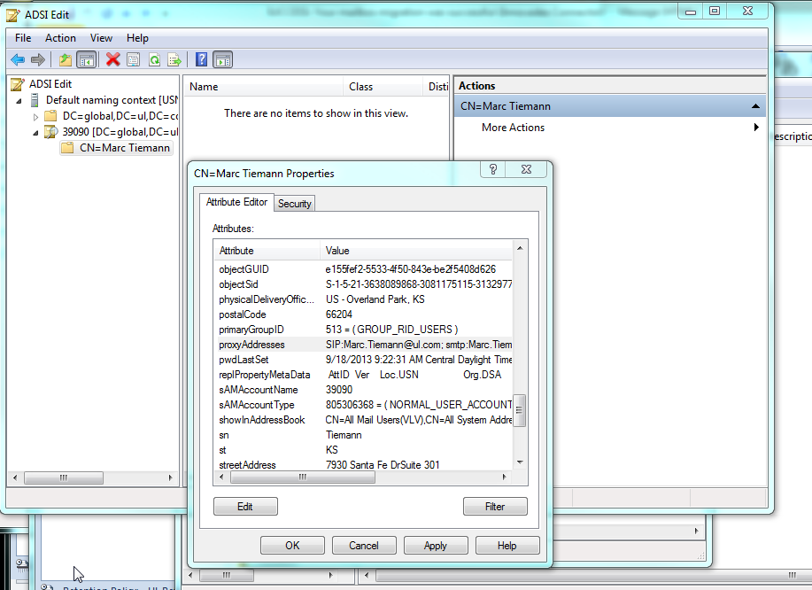

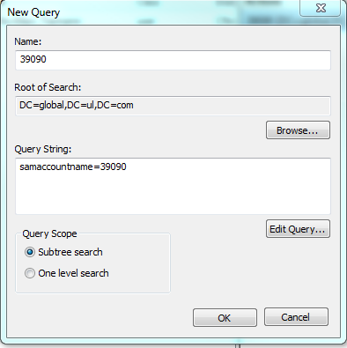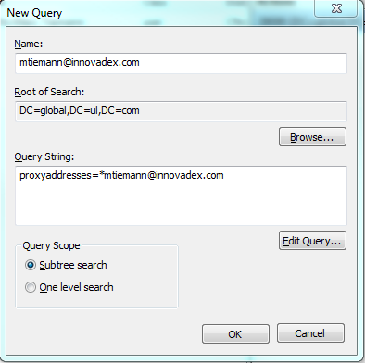

http://community.office365.com/en-us/forums/148/p/187089/548048.aspx
http://community.office365.com/themes/groups/generic/forums/thread.aspx?ForumID=148&ForumThreadID=185809&GroupKeys=en-us/

- community.office365.com/.../162308.aspx
community.office365.com/.../160948.aspx

DirSync:
- Log on to the appropriate directory synch server (Server USNBKD501P). On that server, navigate to C:\Program Files\Microsoft Online Directory Sync folder. Within that folder, double click the file "DirSyncConfigShell.psc1"
- At the prompt, type "start-" (without the quotes) and then hit the TAB key. The TAB key will complete the appropriate command, in this case "Start-OnlineCoexistenceSync"
- Uses SVC.UL.O365@ul.onmicrosoft.com cloud only account (Ntxen1161)

